DCI-SL | the International day of the girl October 11

Children and Youth Advisory Board| DCI-SL

Background
As part of our mandate to protect the rights of the child whether in conflict or in contact with the law and also to complement the effort of government, Defence for Children International also stands to protect and promote quality education for the girl children and support in the achievement to promote Gender Equality Empower girls and young women
Unfortunately, the opportunity disparity between boys and girls in education and other socio economic and political rights is great in communities. On December 19, 2011, the United Nations General Assembly adopted Resolution 66/170 to declare 11th October as the International Day of the Girl Child, to recognize girls’ rights and expose the challenges girls continue to face around the world.
This year, as the international community assesses progress of the past Millennium Development Goals (MDGs) since their adoption in 2000 and the new set of goals to be achieved by 2030, girls born at the turn of the millennium have reached adolescence, and the generation of girls born this year will be adolescents in 2030. As we reflect on the achievements of the past 15 years and plan sustainable development goals for the next 15 years, it is an opportune time to consider the importance of the social, economic, and political investment in the power of adolescent girls as fundamental to breaking the intergenerational transmission of poverty, violence, exclusion and discrimination and to achieving equitable and sustainable development outcomes.
Therefore Defence for Children International will coordinate the Children and Youth Advisory Board in Koinadugu to observe the day and also do a one week activity to advocate for girls education.
Problem and Justification
In Koinadugu District, there are many barriers that prevent girls from acquiring quality education. Even though education for girls in this part of the country is gradually improving, there are still issues that hamper access; retention and completion to at least Junior Secondary School (JSS) are a serious challenge. Among the barriers to girls’ education is the cost: here, cost does not only involve a tuition fee but the uniform, school bags, learning materials (books, pens etc).

Adolescence Sexual and Reproductive Health education is very crucial for the school girls. This type of education, if provided may help girls to develop positive life skills which will go a long way to prevent early/forced marriage and or teenage pregnancy which account as one of the reasons for girls to drop out of school. With reference to the commemoration of the Day of the African Child on June 16th, 2015, it was by a senior officer in the Ministry of Social Welfare Gender and Children’s Affairs that Koinadugu district has the highest rate of early/forced marriage and teenage pregnancy.

School related gender based violence is another hindrance to girls’ education: arguably, teachers and peers have been seriously accused. Therefore, if parents/guardians find out that the school is not safe, they may withdraw their girls from school. The stereotyped cultural/ traditional belief which holds that schools are for boys and not for girls is another serious barrier. Because of the inadequate awareness on the importance of girls’ education, many parents prefer to send their girl children into early marriage. Moreover, the high rate of teenage pregnancy in the district has also contributed to the high rate of drop out of young girls from schools.

As a component of what contributes to the provision of quality education, the Water Sanitation and Hygiene (WASH) if not adequately and appropriately addressed can send girl children out of school in a high number. Being that girls/women have special needs, they need adequate supply of water to keep them clean and healthy. Toilets provided for pupils (boys and girls) should kept far apart from each other in a relative distance to let girls who have reached the puberty stage feel safe and dignified while in school.

These challenges have been threats to the state’s government and us as nongovernmental organizations in our efforts to foster girls’ and women’s empowerment. Therefore, the need to increase awareness amongst stakeholders to ensure girls’ education is extremely necessary.

Objectives
- To raise more awareness on the importance of girl’s education
- Commit stakeholders to act now in promoting and improving girls education
- Commit duty bearers to increase and improve on investment in girls education
Methodology
- Community based counseling
- Strengthening partnership for girls’ education at community and district levels
- Advocacy and sensitization through the community radio
- Community/school engagement on issues hindering girls’ education (Community dialogue)
- Use of adolescent theater/drama groups
Activities
- Schools visitation
- Radio Discussions
- Debate competition for Junior Secondary Schools
- Football game
- Match pass and conference
- Radio Quiz competition

Activity I. Schools Visitation
The CYAB and the DCISL took upon school visitations to six (6) secondary schools in Kabala to inform them about the 11 October and also to raise awareness on studying hard and pay attention in class as it is to be a priority of every girl going to school. These schools were also invited to partake on the school debate competition, match pass and conference.
Activity II. Radio Discussion on the Awareness of the movement

Upon observing the International Day of the Girl October 11 2015, the Defence for Childen International and partners in child protection engaged on active radio awareness in which each radio presentation discussed on issues affecting adolescence girls. With the sponsors from UNICEF through Cause Canada and OXFAM, radio programs were paid for with which each program has a topic of discussion. Below is a table to show the activity outline.

Activity | Date | Responsible person
Awareness on, Early marriage and teenage pregnancy | 17th September | FAWE, CAUSE, CYAB, CFN, IBIS, DCISL
The Importance of Girl’s education, Poor parenting | 1st October | DCI-SL, CDHR, MEST, FAWE and CAUSE
Discussion on Foot Ball Match, the Importance of the debate and quiz competition. | 6th October | Koin-GEM (Koinadugu Girls Education Movemnt)
Radio discussion on the activity event and football match | 9th October | Koin- GEM/CAUSE
Quiz Competition | 12th October | DCI-SL, FAWE, CAUSE, CDHR,

Activity III. Debate competition for Junior Secondary Schools
The Debate was organized by DCI-SL in coalition with the members of KoinGEM in order to engage children to be able to do research, study wide and also be able to speak in crowed and develop a sense of confidence and self esteem.
The different schools were informed about the debate and also as schools to render their supports as to what role they will be playing. The debate was organized only for junior secondary Schools in forms 1 and 2. Each school was given letters which had all the outlined activity of the debate including the debate topics and what school will be for the motion and against the motion. The schools were to produce two (2) participants and ten (10) as supporters.
On the 7th October, 2015 the Debate took place at the District Council hall from 9am to 1pm. Schools gathered with their teachers all seated together on one side of the hall to interact and all invitees and KoinGEM members seated on the other side of the hall.
The Judges were heads of institutions and of high reputations were chosen by members in order to have a free and fear judgment of the competition. They are; Saio Mansaray of Pegeay Woobay Foundation, Deputy Council Administrator of the Koinadugu District Council, District Coordinator ASJP, and Director of IBIS Organizations and the Chairperson Madam Doris Maturi Lusani of OXFAM.
The participants balloted for them to have the first set of schools that will start the debate. Aunty Saio read the debating rules and also what the judges will be putting points for. Some of them are confidence, timing, presentation, dress code, grammar etc. Each participant was given 5minutes to do her presentation.
At the end of the presentations, the judges read the result given the reason why they decided on the winners. Since there were three topics for six schools, the judges decided to give each debate battle to have the best speaker whether it is for the motion or against the motion. The day ended with refreshments. Below is a list of the debate program.
Schools debating | Topic | # of debaters per school | For the motion | Against the motion | Date | Time | Location
KSS versus CRC | Girls can become better leaders than boys | 2 | CRC | KSS | 7th October | 9am to 1pm | KDC hall
AMASS versus LOMA | Social media is negatively affecting girls education | 2 | LOMA | AMASS
UMC versus Kabala Girls school | Pregnant girls should be allow to school | 2 | Girls school | UMC

Activity IV. Football game

The Football game organized for the ladies working for Non Governmental Organizations (NGO) and Nurses. This is to promote NGO ladies as role models teaching young girls that you can have enough fun when you are educated and also empowered.

Cause –Canada championed in organizing the team and also trainings at the RC primary School field every 4pm. The football trainings brought positive interactions amongst different organizations and also created in establishing teamwork and cordiality.
The game was played at the Kabala Secondary School Field on the 9th October, 2015. The NGO ladies team camped at the District Council hall at 12miday to have their launch and also to change in their football gears. At 4pm the field was full with supporters for each team including children to watch and support the match. The game was played for 90munits. The nurses won 2 to 1 against the NGO ladies.
Activity V. March pass and Conference

Every year October 11 is celebrated as the Day of the Girl Child right across countries in order to reflect on the Girl child Rights of education and empowerment. Government, NGO’S, UN offices and Stakeholders gather to discuss the challenges and opportunities girls face in the world
In Sierra Leone, the National event of was organized in Kabala town at the Community Center- Koinadugu district. The Ministry Education, Science and Technology in collaboration with development partners including Defense for Children International, CAUSE Canada, Oxfam, IBIS, CDHR, CRS, Street Child, FAWE and UNICEF among others led the coordination of the event. The national theme for this year is “the power of the adolescence: vision 2030.
The day was observed as children matched peacefully from the RC Primary School right around the township onto the Community Center District hall with different messages written on ply cards and wearing different printed t-shirts with messages of educating and empowering girls. This year, it was organized to condemn Child Marriage, teenage pregnancy and school dropout advocacy forum. Statements were made on the importance of the day, meaning of the theme, effects of illiteracy to the children, community, and the country.
The Children and Youth Advisory Board (CYAB) staged a play which passed on a strong advocacy message that girls have the right to education.
Each statement ended with an advocacy message to ensure effective laws and implementation on ending child marriage, abuse and violence against girls. Child protection agencies made statements including UNICEF, Council of Paramount chiefs,
A child representative from the group Children and Youth Advisory Board (CYAB) recently formed by DCI-SL and also a member of the Children’s Forum network Fatu Sewanatu Mansaray read and presented the Position Paper to the Stake Holders of Koinadugu. A girl beneficiary of the Cause Kids program; Cause-Canada Janet Mah from the WCS Primary School gave the vote of thanks
Activity VI. Radio Quiz competition

As part of education the main focus of the e to promote quality education for girls, DCI SL organized a primary school quiz competition for girls broadcasted live on the radio Bintumani on Sunday 11th October 2015, a 2 hours program starting from 2pm to 4pm.

This quiz was for children to develop research and reading skills, also for children to learn how to study their school work. It was a way of motivating parents to study their children at home and also education should be a priory for every girl child and parents.

Questions were drawn from the UN CRC Act 2007, school syllabus, EBOLA and Current Affairs. The Ministry of Education and Cause- Canada provided prizes the children will receive after answering a question correctly. The questions were read to the public and children called chosen question they want to answer.

Result on Activities
- Schools Visitation
- Awareness about the Girls Empowerment
- Principals are involved to support the organization, its focused goals and objectives

- Radio Discussions
- People participated in calling and giving contributions about the issues surrounding girls education
- The discussion brought awareness on the importance of girl education
- People were told about the upcoming activities and as a community they participated on the football match and march pass.

- Debate competition for Junior Secondary Schools
- Children who participated developed confidence and self esteem
- Through the children’s presentations child protection agencies were able to know how well sensitization on education is known to children
- The presentations raised awareness on both the negative and positive aspects of the debate topics which the children handled very well.
- This has motivated schools to be doing L and D S in schools so that children can be able to talk in large crowds

- Football game
- Friendship, teamwork and cordiality amongst women of the different organization
- Girls saw the ladies as role models
- This football match also served as a means of raising awareness to people about the importance of education.

- Match pass and conference
- Advocacy messages written on van cards were seen by everybody who was present and understood and they will in turn pass the messages to others who were not around.
- The town was shaken by the voices of the children
- Children had the chance to speak loud to the whole community
- The children were given a right; to be part in the decision making of speaking out the minds
- Parents are now aware that there are strong organizations that are complementing the government’s effort to provide support, protection and guidance to children.

- Radio Quiz competition
- Parents who helped their children in calling to answer and those who listened now know areas they should teach their children at home
- Questions from the Childs Rights Acts and Ebola served as a reminder to people that Children have rights and EBOLA still exists.
- Evaluations were done by organizations to know how far their advocacy for education has reached the people.
- Children who did not win were influenced by others who won to study had and pay attention in class.
- Created an opportunity for quiz competitions should be continues for children to study.

ANNEX 1. Girls Position Paper to the Stakeholders, Government and NGOs
KOINADUGU ADOLESENT GIRLS POSITION PAPER DURING THE INTERNATIONAL DAY OF THE GIRLS CHILD CELEBRATION OCTOBER 2015
Madam Chair, UNICEF Rep, Ministries, Council of Paramount Chiefs, NGO’s, Civil Societies, of Koinadugu, all protocols observed.
I feel honored to deliver this statement to the stakeholders on behalf of the children of this our beloved district, Koinadugu.
On behalf of the children, I would like to thank the government and its development partners for their continuous efforts in the development of girl child.
However, Madam Chair, we are gathered here today to observe the International Day of the Girl child with key focus on empowering adolescence girls, which is crucial for development in our society.
In Koinadugu District, there are many barriers that prevent girls from acquiring quality education. Even though education for girls in this part of the country is gradually improving, there are still issues that hamper access; retention and completion to at least Junior Secondary School (JSS) is a serious challenge. Among the barriers to girls’ education is the cost: here, cost does not only involve a tuition fee but also the uniform, school bags, learning materials and even with extra payments for aside classes, assignment and hand work (instead of practical work) etc. In addition, the practice of early marriage has hindrance to the development of the girl child and the nation as a whole.
Adolescent girls have the right to a safe, educated, and healthy life, not only during these critical formative years, but also as they mature into women. If effectively supported during the adolescent years, girls have the potential to change the world both as the empowered girls of today and as tomorrow’s workers, mothers, entrepreneurs, mentors, household heads, and political leaders. An investment in realising the power of adolescent girls upholds their rights today and promises a more equitable and prosperous future, one in which half of humanity is an equal partner in solving the problems of climate change, political conflict, economic growth, disease prevention, and global sustainability.
In Koinadugu District, the issue of early marriage, teenage pregnancy, school dropout, prostitution among others remains un-addressed and limited measures are taken by the stake holders to arrest this trend. Though, some patchy efforts were made by the government, civil society and child protection organizations, but they were not enough even to make it a main stream issue of children particularly girls. We need to emphasize on strengthening a responsive local government structures at the district level, so that Girls can have free education.
Currently Government and its Partners, INGOs, NGO’s and CBOs are working together to build a child protection system in the country. Remember! A strong component of child protection system strengthening is capacity building of children themselves so that they can add their voice to the process and also be in position to resist potential abusers.
In recent times there have being progress in reforming the laws and formulating new policies to protect children and advance their rights. These polices include the Education Act 2004, the Anti human Trafficking Act 2005, the Child Rights Act 2007 and the Sexual Offences Act 2012.
Government has also set up structures at chiefdom and district levels that are expected to identify issues that affecting the child. These structures like the Girls Education Movements, Mothers Club, Council of Sowes, Child welfare committee, Traditional Birth Attendants, are there to guide the girl child through stages of development in the community.
However the adoption of these policies has not created desired impact on the children and young people especially the Adolescence Girl. There are major issues affecting us as lack of empowerment which are as follows:
- Adolescence Sexual and Reproductive Health education is very crucial for the school girls. limited awareness amongst teenage girls about puberty and sexual reproductive health
- School related gender based violence is another hindrance to girls’ education: arguably, teachers and peers have been seriously accused.
- Traditional beliefs and practices – e.g. settling of family conflicts through handing in the girl child in marriage.
- Weak enforcement of laws and policies to protect the girl child.
- Lack of Guidance Counselor in schools
- Lack of Family Life Education (FLE) teaching in schools
- Lack of life skill building trainings in schools and community
- Chronic poverty
- Limited of scholarships to motivate girls
- Poor parenting
- No child friendly recreational centers in schools that will attract the child to come to school every day.
- Lack of proper toilet facilities.
- Corporal punishment
- Sexual Harassment of teachers to give high grades
- Domestic violence
- Teenage pregnancy influence amongst peers.
Keeping in view of the above, we the Adolescent Girls are establishing the following recommendations:
Judiciary/legal Services
Government through the Ministry of Social Welfare, Gender and Children’s Affairs and line ministries must ensure the legal required age of marriage is 18 years and above and to also fast track the harmonization of all laws regarding marriage in its ongoing constitutional review ( Child Right Act, UNCRC, Customary Law and the Sierra Leone Constitution).
Government and partners should ensure there is a sitting magistrate in all districts addressing children’s welfare issues and also strengthen the law enforcement bodies, for example the police (Family Support Unit FSU) to enforce the laws. Girls in contact or in conflict with the law must have easy access to legal aid and the legal aid board should be seen as visible and effective.
Education
- Government through the Ministry of Social Welfare, Gender and Children’s Affairs and Ministry of Education, Science and Technology to ensure all legal instruments on children (Child Right Acts, UNCRC) related to children must be incorporated into the school’s curriculum.
- Government must ensure all girls have access to affordable quality education.
- Government should provide grants to outstanding girls up to tertiary institutions.
- There should be trained and qualified female guidance counselors in both primary and secondary schools.
- Teachers must know the teachers code of conduct.

Health
- Free health care facilities for all children are provided including the adolescent girls
- Access to quality health facilities in schools (eg Water and Sanitation facilities in all schools)
- Medical team providing workshops for adolescent girls in community levels to discuss Sexual Reproductive issues.
System Strengthening
- The Government through the Ministry of Social Welfare, Gender and Children’s Affairs and partners should provide support to Community Advocacy Groups like the mothers clubs.
- Government, partners and communities to promote child participation in all decision making processes.
- Government should provide the necessary platform for massive sensitization to stop child marriage.
- Government must ensure there is a Memorandum of Understanding with all stakeholders, emphasizing the need to eliminate child marriage.
- Parents and families must be engaged by child protection partners and the ministry to promote good parenting skills at all levels.
- Government through the Ministry of Social Welfare, Gender and Children’s Affairs to strengthen and empower community structures such as CWCs, CAGs, and Mothers Clubs etc. in chiefdoms
- Traditional leaders, religious leaders and local authorities to ensure that children are not used as bargaining chips in settling disputes a practice in the Koinadugu District.
- Government must provide psychosocial support for all child marriage victims.
Institutions
- The District Council must ensure that Community Based Organizations perform their duties in the community and not to compromise any abuse or violence against girls and also do community based counseling.
- The Government must strengthen partnership for girls’ education at community and district levels
- Advocacy and sensitization through the community radio
Non Governmental institutions
- Do Community and school engagement, Community dialogues on issues hindering girls’ education and development.
- Use of adolescent theater or drama groups to impact positive peer influence amongst girls
- to raise more awareness on the importance of girl’s education
- commit stakeholders to act now in promoting and improving girls education
- commit duty bearers to increase and improve on investment in girls education
Customary Community Leaders
- Enforce Bye-laws to punish any accuse of rape or gender base violence
- Stop compromising early marriage and teenage pregnancy
- Monitor Community Base Organizations on their activities if it is in the best interest of the girl.
Parents
- Mothers should teach their daughters about early puberty.
- Fathers should encourage their daughters to educate
- The mother nor the father should disrespect the other in the presence of the children
- The parents should not encourage the girl as breadwinner in the home in receiving gifts from men.
- Parents should develop the same confident and trust in boys to girls
- Girls friends and peer groups should be monitored
- Continuous monitory of school work
The government, stakeholders, community leaders, NGO’s, and Parents, on behalf of the adolescent girls, myself as the Koinadugu Girls Ambassador of this meeting we are appealing for these recommendations highlighted to be swiftly acted upon.
I want to remember you that, “When you educate a girl you educate the nation”.
I want to give a special thank to the Koinadugu Girls education Movement for their influencing support toward this movement.
I thank you all for your attention
Activities Pictures Report

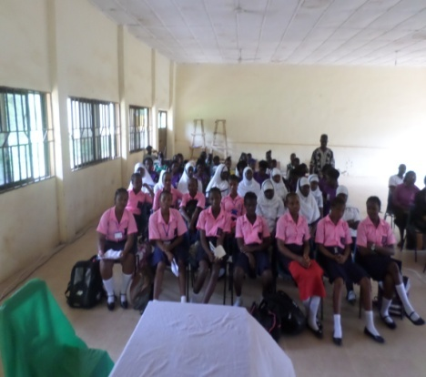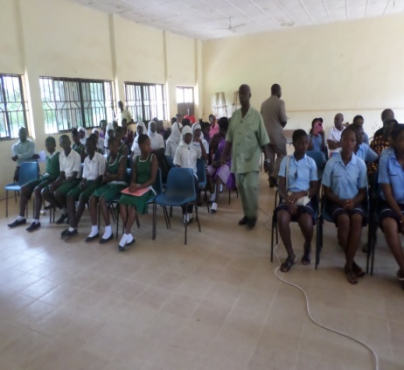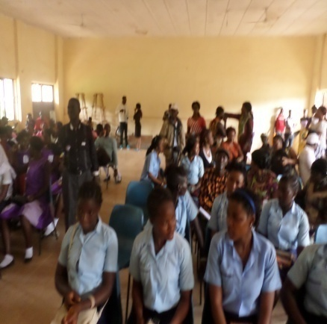
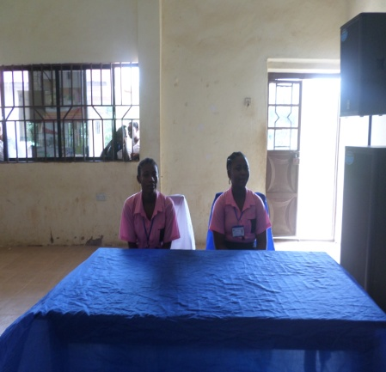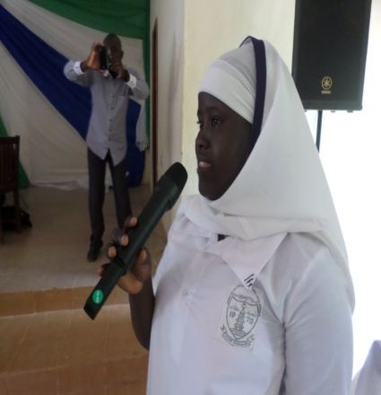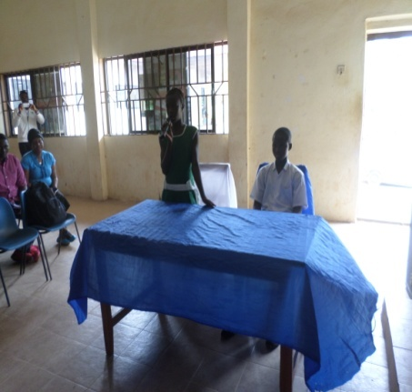
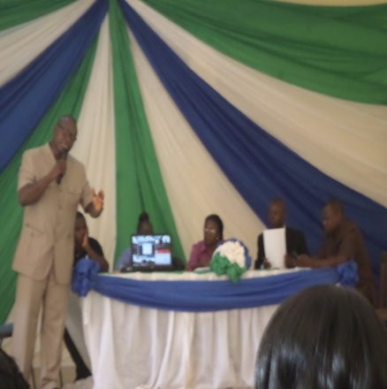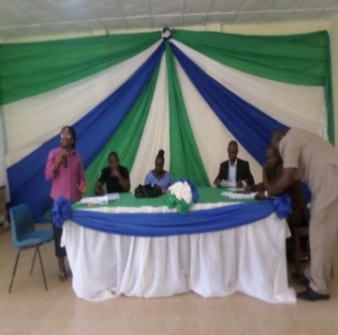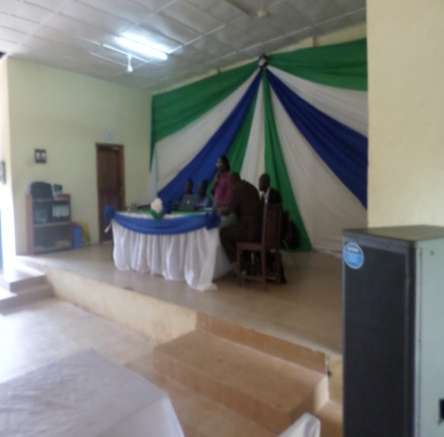
The Inter- Junior secondary schools debate competition held on the 7th October, 2015 at the Koinadugu District Council Hall
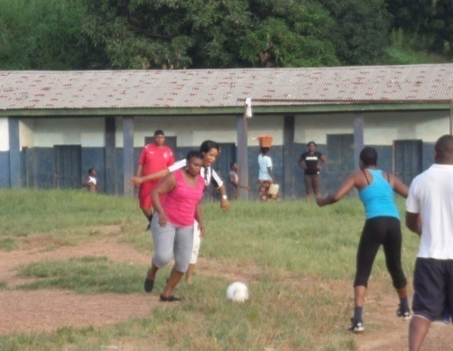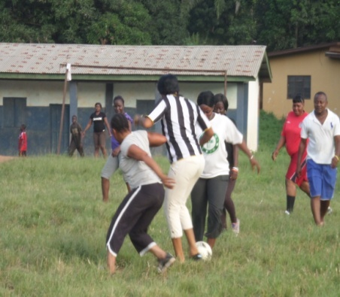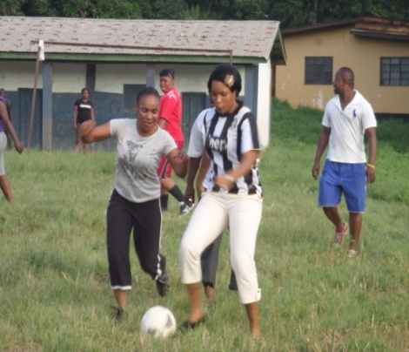
Football training at the RC School.
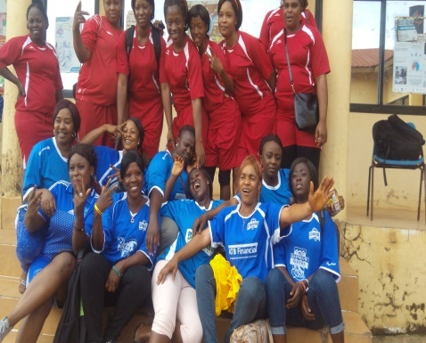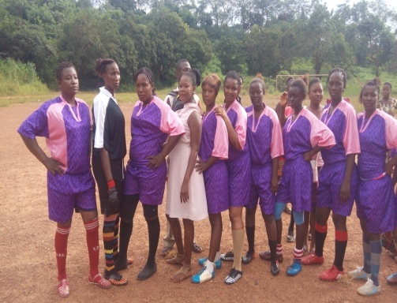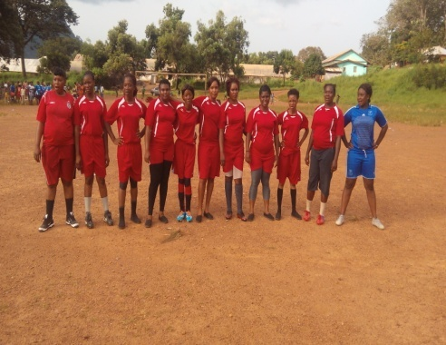
The football match between the Non Governmental Organizations and the Koinadugu Nurses team played on the 9th October, 2015 ant the kabala Secondary school field.
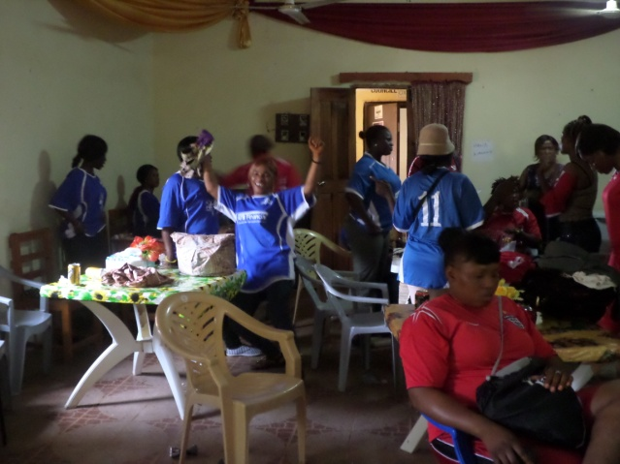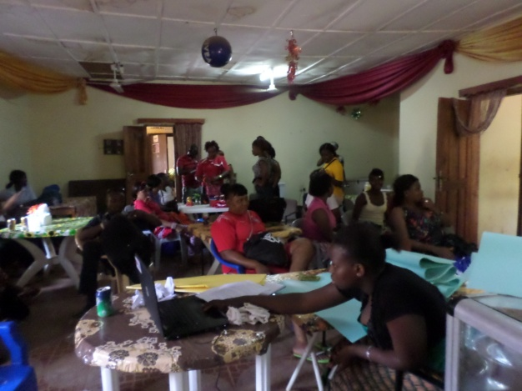
Football Team camp
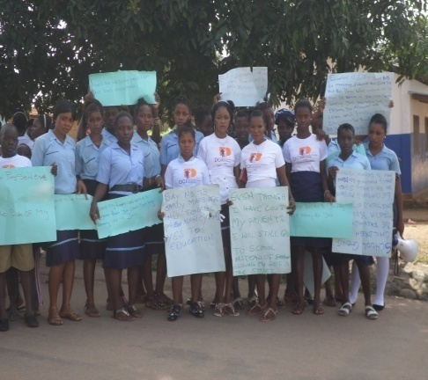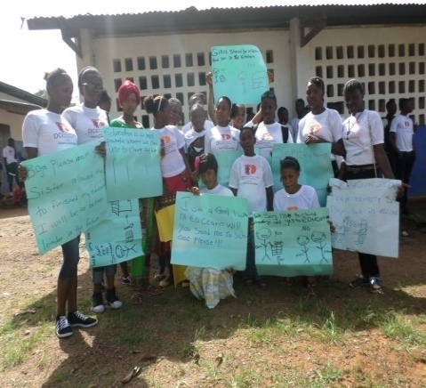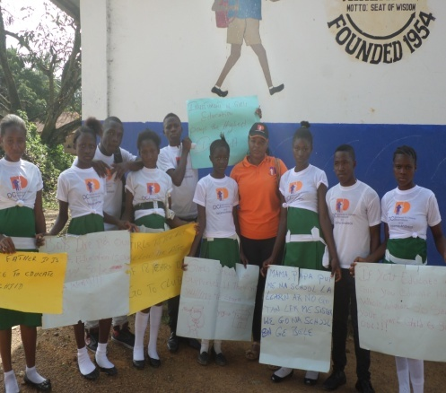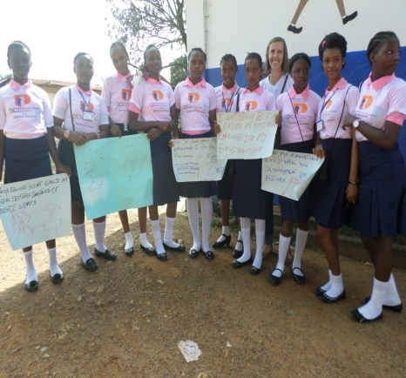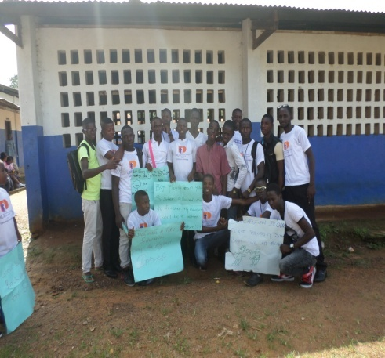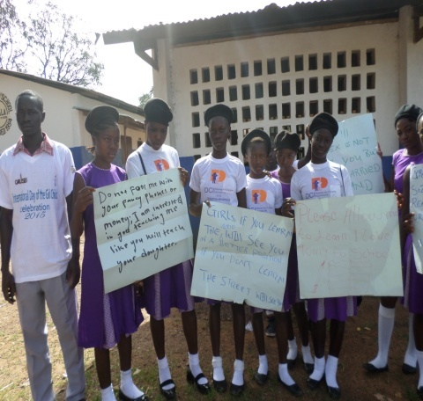
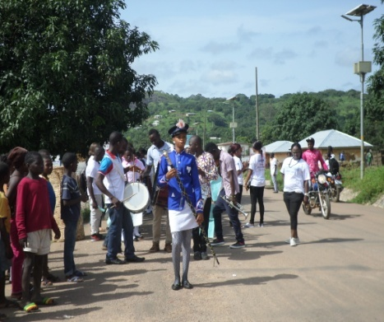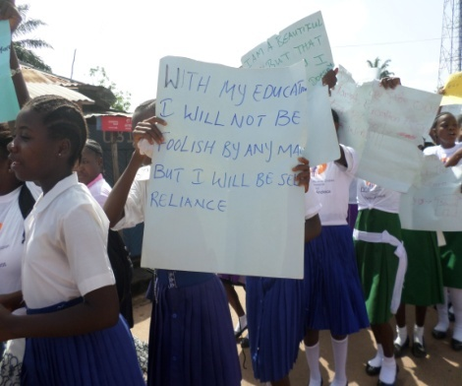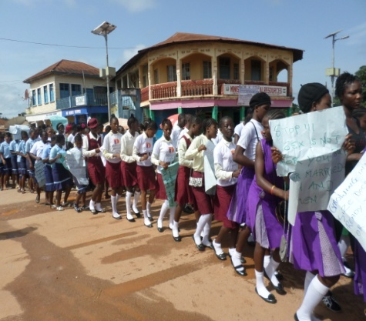
Different schools represented for the March pass
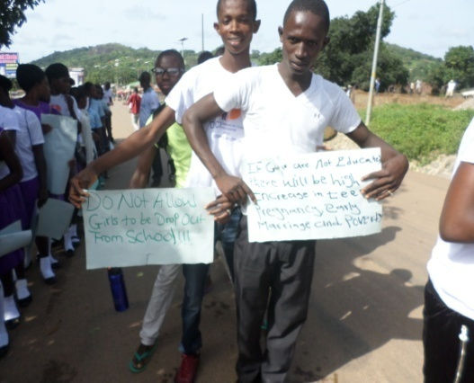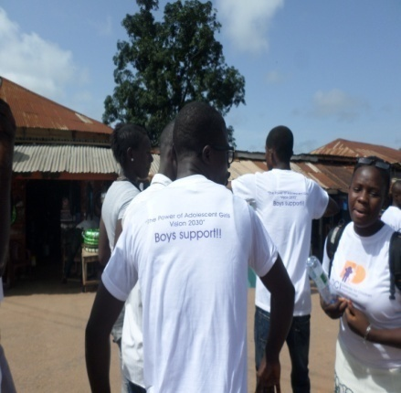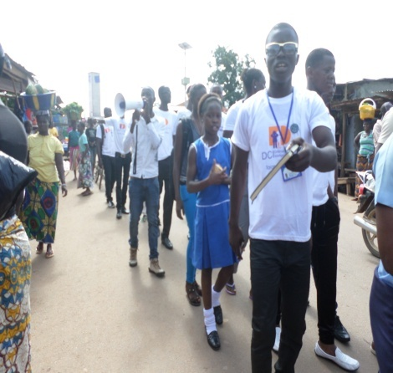
Boys in support of girl’s education
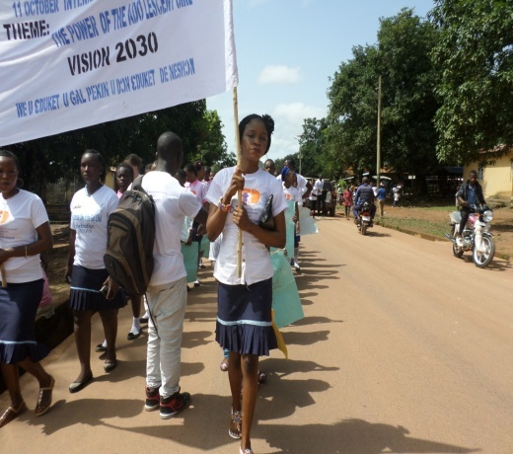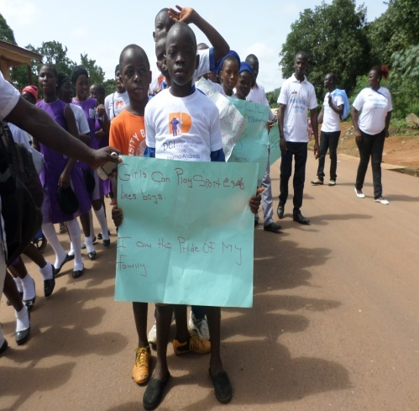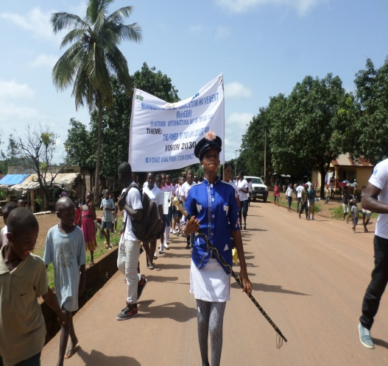
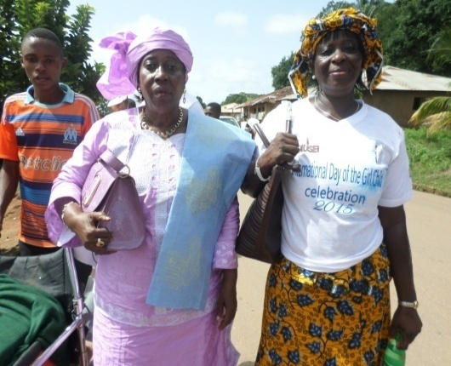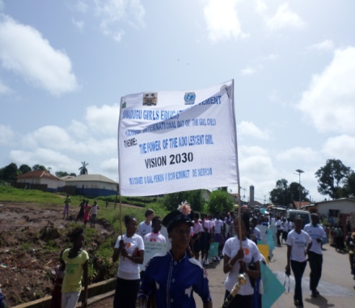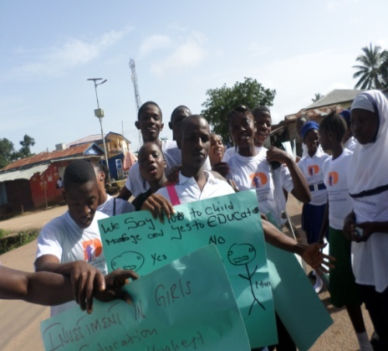
March Pass on observing the Girls Education week, for the October 11 -International Day of the Girl 10th October 2015.

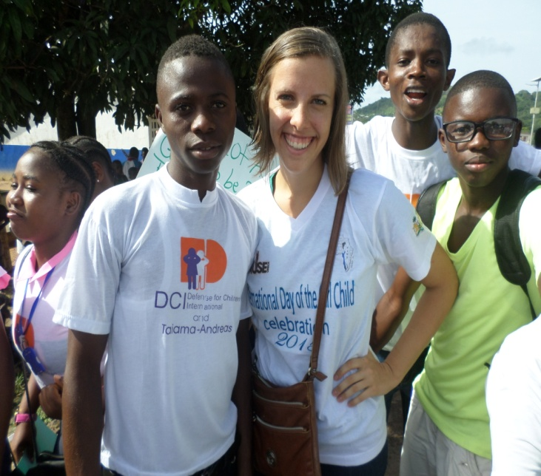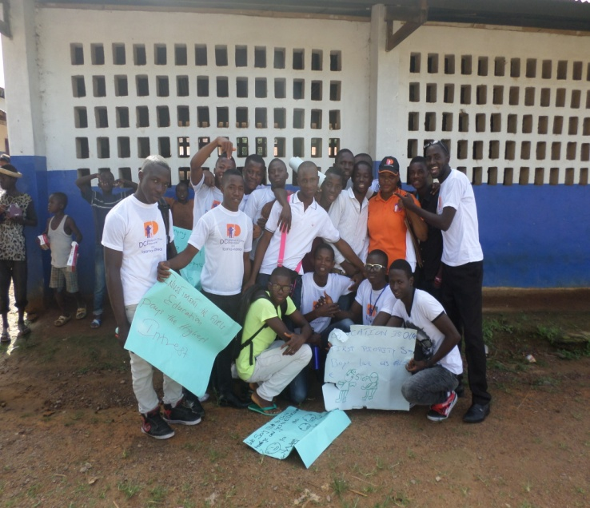
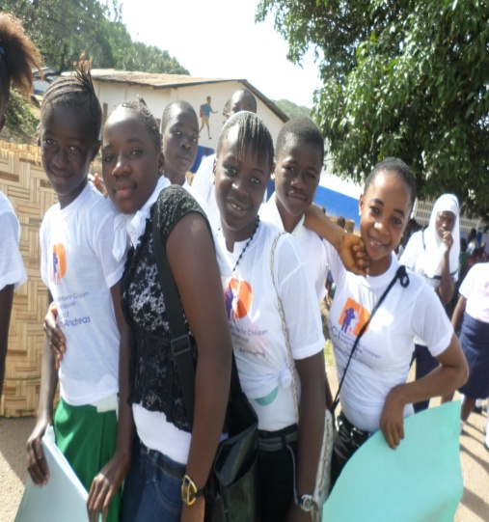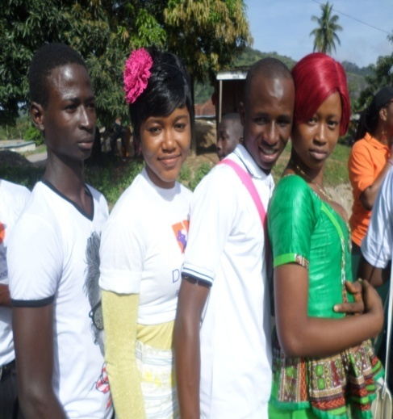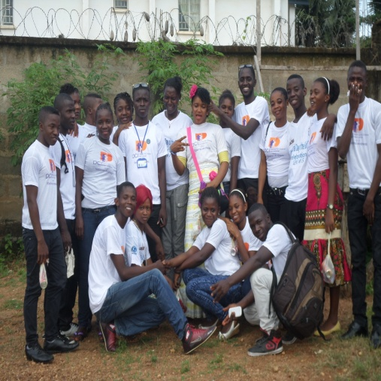
Children and Youth Advisory Board (CYAB)

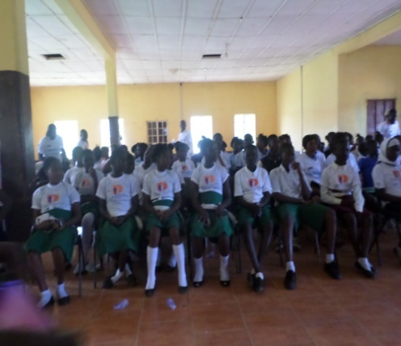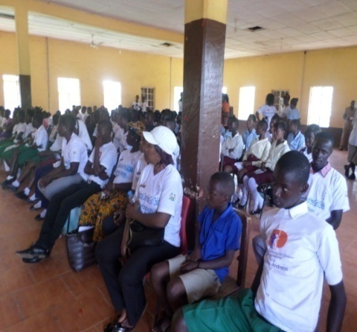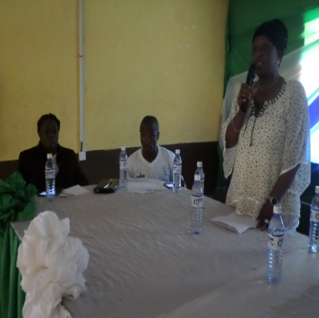
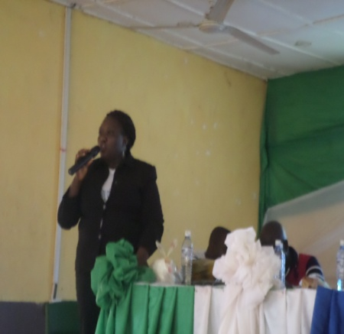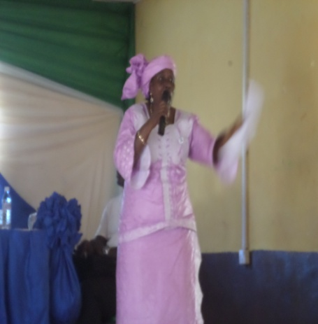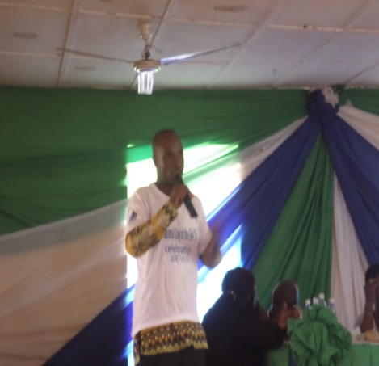
Statements given by stakeholders on the importance of education.
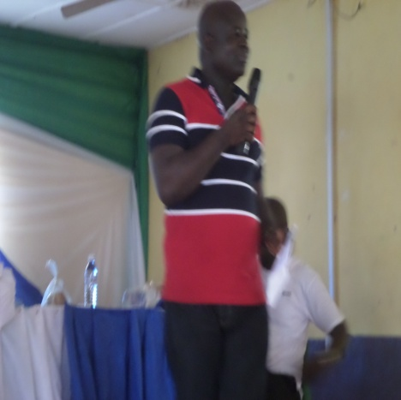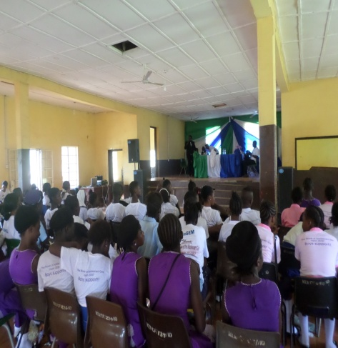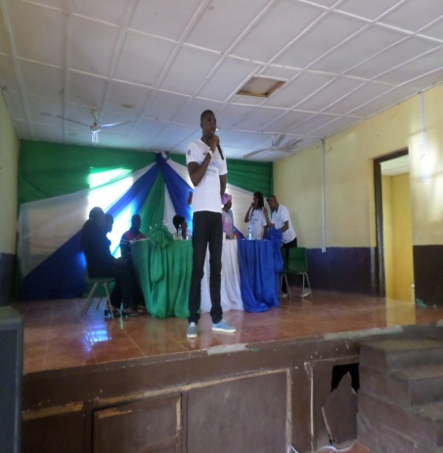
The Conference on the 10th October 2015 at the Koinadugu Community Center, statements given by stakeholders on the importance of education.
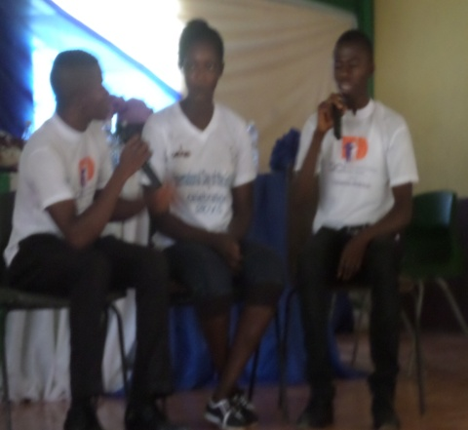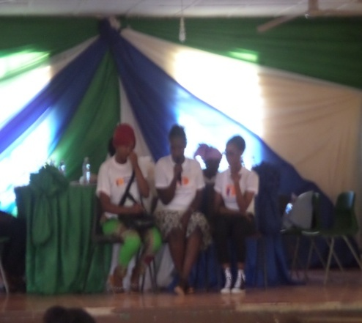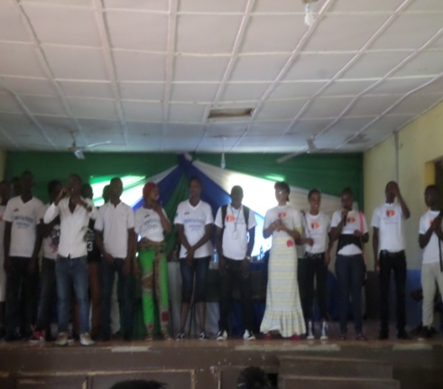
The Children and Youth Advisory Board (CYAB) staging a play title “the importance of Girls Education”
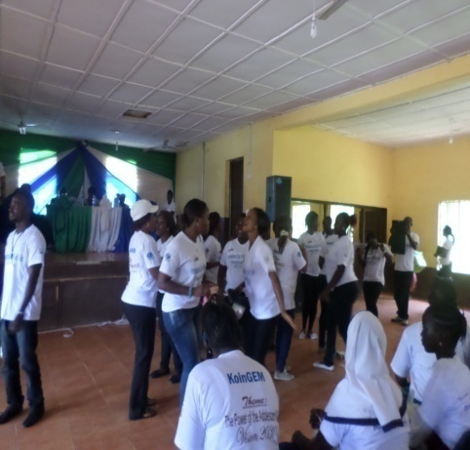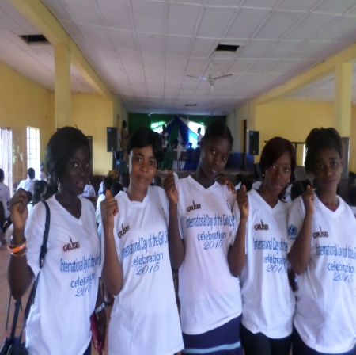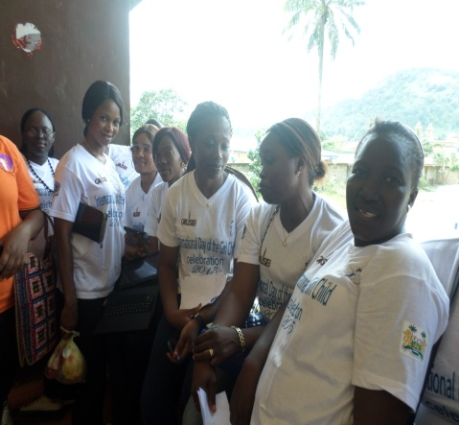
NGO Ladies of KoinGEM celebrating Education and Girls Empowerment
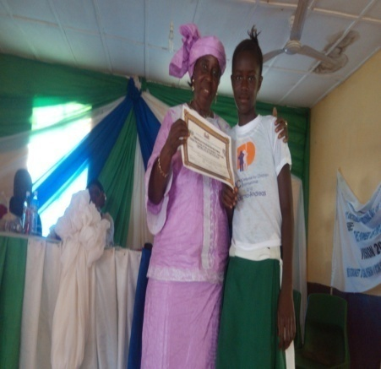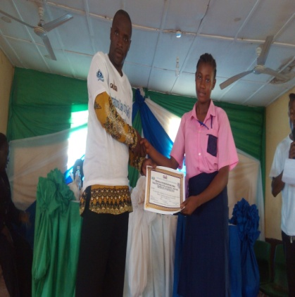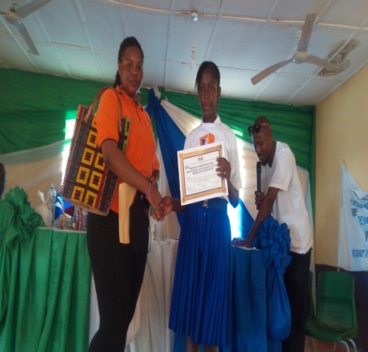
Children who took part in the debate reciving certificates
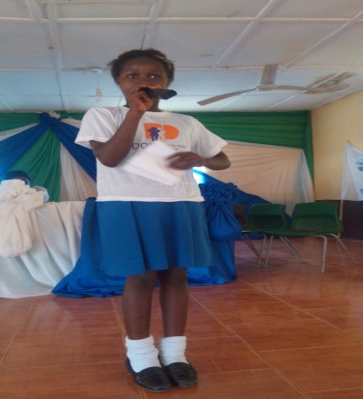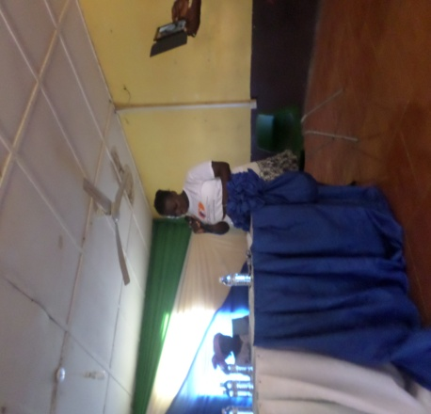
Janet Mah giving the vote of thanks Fatu Mansaray presenting the Position
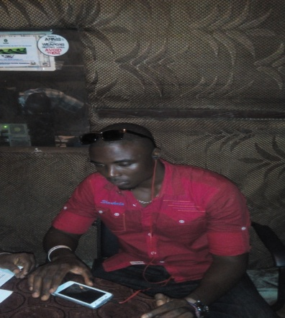
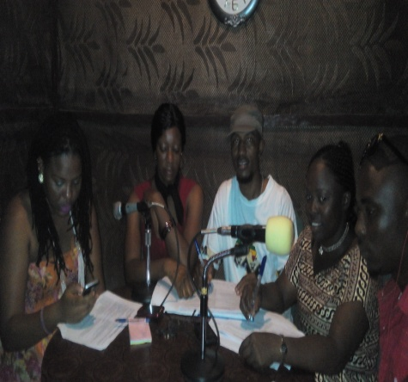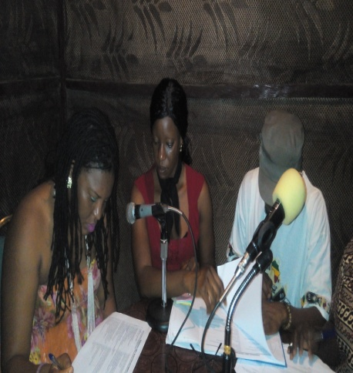
Radio quiz competition for primary schools girls
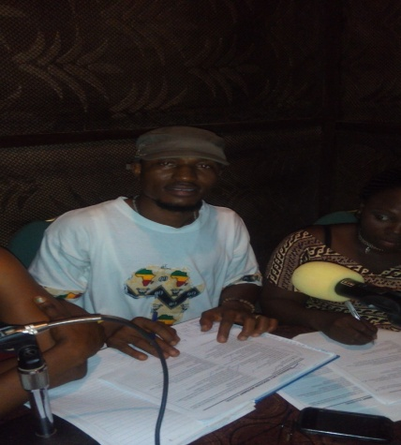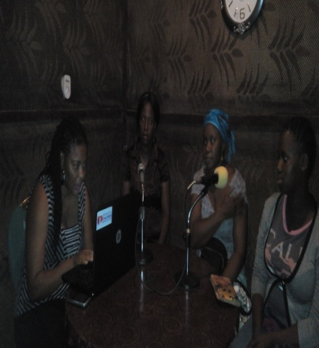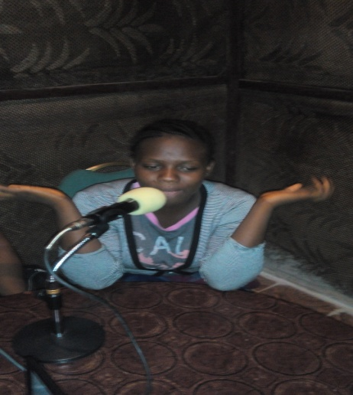
Radio discussion and awareness raising
.
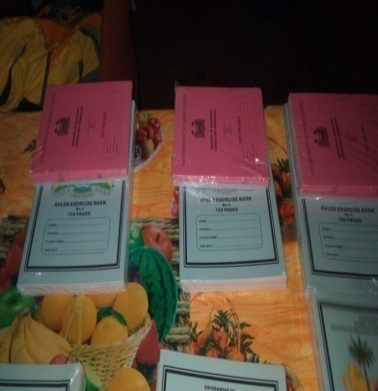
Prizes for winners for the radio quiz competition

