Defence for Children International Sierra Leone (DCI-SL)
The Sierra Leone Chapter of the worldwide movement for children's rights

Project: Strengthening Children and Youth Advocacy Board.
Organization Group: The Children and youth Advisory Board (CYAB), Kabala.
Date: July to September 2015 Report.
Activities:
- Refresher Training
- Visit to the Blind School
- CYAB weekly meetings.
- Engaged in Trainings Organized by other Agencies
- Drama performances in Advocacy.

- Refresher Training
DCI-SL provided training for both old and new members of CYAB. Because of the various activities during the last year, the project attracted new members who joined the group. Some of them were brought in by friends in the group and others were attracted by the school assembly. Some of the old members drop off the project because of traveling to the city and other district to attend schools.
On the 14th July, 2016, the Director Abdul Manaff Kemokai accompanied by the Program Manager for DCI-SL Makeni, Raymond Senesie made a visit to Kabala in order to monitor and supervise the project.
On their visit the Director did a training with the children in order to build in their capacity and also to improve on what they have being doing. The training was a dialogue discussion between the children Mr. Kemokai and Raymond Senesie.
The training was done on a two way approach. Director asked the children to show case on how they do their meetings and how they discus and have their action plans for set activities. The group in a child friendly manner showcase their meeting activity and advocacy strategies whilst DCI-SL staff observed.
After they finished show casing, Director together with Raymond made facilitated the training which focused on the following topics:
- Advocacy/lobby strategies and skills
- Social mobilization
- Planning- using child friendly tools
- Monitoring and evaluation- using child friendly tools.
The training was done in a child friendly discursive manner where in the children asked so many questions and also answered questions. Raymond Senesie who is also implementing similar project in Makeni learnt a lot from the children. He told the children that he will teach his group in Makeni some of the ice-breakers and games the children did in the sessions of the training and the manner at which they handled their meeting.

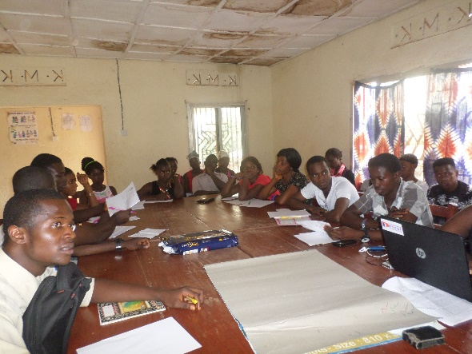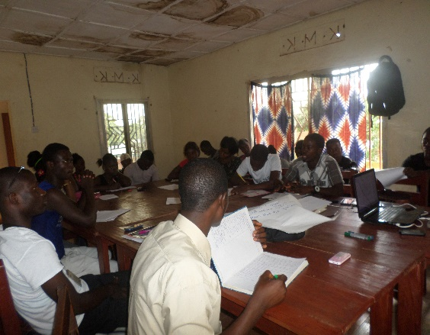

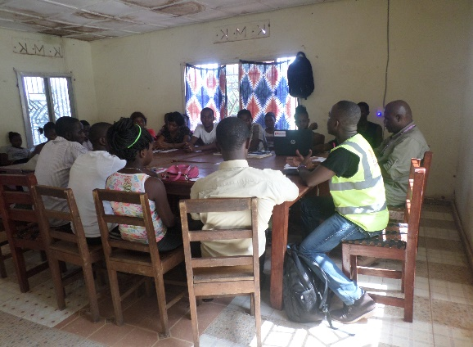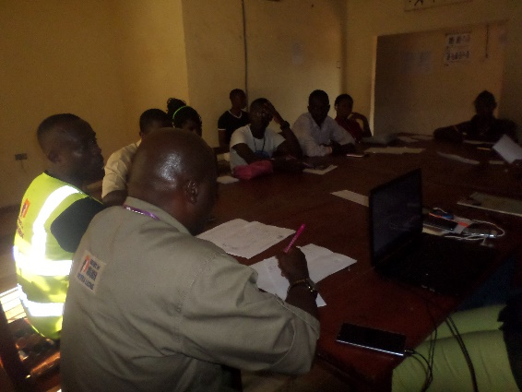
Training Sessions with Director, Program Manager DCISL Makeni and CYAB
Objective
- To supervise and monitor the ongoing project
- To increase knowledge amongst children in identifying their weaknesses and improving on them
- To build on their capacity on the approach in advocacy
- To know possible solutions in stopping or preventing child abuse.
- To have knowledge on what they should be discussing in school assembly.
- To welcome new members in the group and also give them orientation.
Result.
- Supervising and Monitor gives the opportunity to improve on the areas that are lacking
- CYAB group are well capacitated on how to go about planning and reporting their actives and implementation.
- Children learned how to go about advocating for their rights and the channel they should use in solving child issues.
- They now know how to identify and report issues that affect them and who they should report to.
- This created a forum for the group to express their views about the project and what they have in mind in sustaining the project.
- The training created an atmosphere for reliability and confidence in discussing issues.
- New members were well informed about the project and its objectives.

- Visit to the Blind School
CYAB together with the staff of DCI-SL (Director, Program Manager Makeni and project Officer) made a second visit to the school of the blind to donate clothes and beddings to the school.
The children packed clothes that were donated to DCI-SL by Don’t Forget the Children Foundation in Holland. They sorted the clothes by age, size and sex for the blind children. At Blind School, the Principal and teachers assembled with the children to receive the gift from CYAB and DCI-SL and the President of CYAB presented the clothes to the school. The Principal showed appreciation and said thank you on behalf of the school.
Objective
- to donate clothes for the blind children
- to know how the blind children are doing
- to fulfill the promise of CYAB made in the 1st visit
Result
- the blind children received many clothes and beddings
- they expressed their appreciation for the visit and the gifts
- the promise was fulfilled

- CYAB weekly meetings.
The group held meetings every 1st and 2nd Saturday in the month always in a child friendly manner. On the chosen days, children will come within the hours of 4pm to 6pm to hold the meeting and they themselves always moderate the meeting.
The meeting’s agenda goes like this;
The meetings will include but not limited to the following agenda items:
- Update from the executive
- Planning for the coming month
- Drama
- Storytelling and sharing of jokes
- Games
- Life skills building
At these meetings, DCI-SL project officer continuously coach them during their meetings. Observe the way they conduct their meetings and take note of all the mistakes that they do. By the end of the meeting, she will come in and correct and also give them additional explanation.
The meeting agenda
- Arrival of children 3:30- 4:00pm
- Prayer
- Welcome Address (President CYAB)
- Introduction of Chairperson.
- Minute read by the CYAB Secretary
- wise words, parables and poems (CYAB)
- Cases identified in school and community
- Identify advocacy issues from discussions above.
- Planning of activities for the next month
- Coaching (Project officer)
- Talent (song, poem, drama etc.)
- Closing prayer.
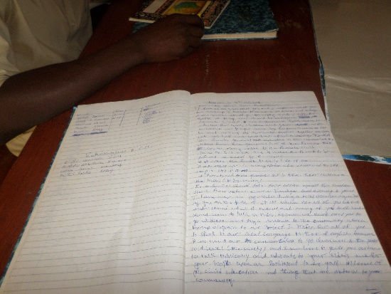
- Refreshment
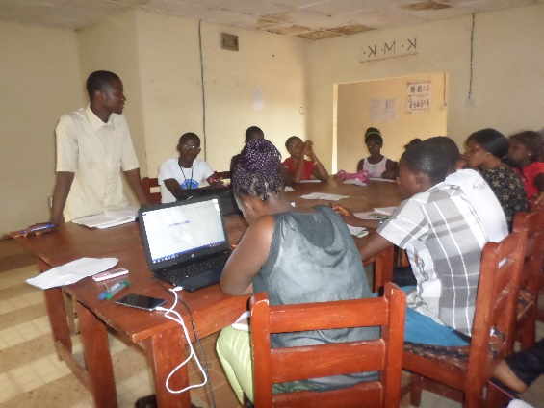
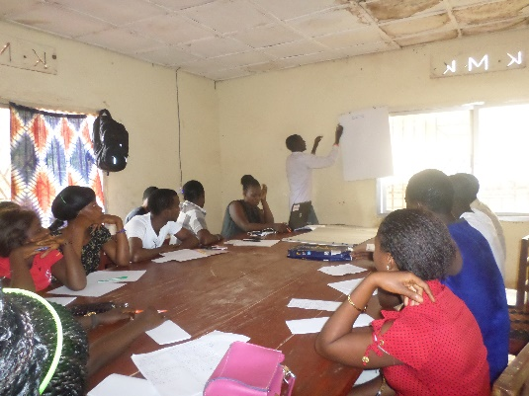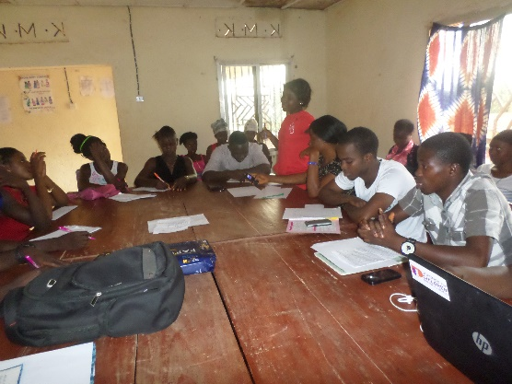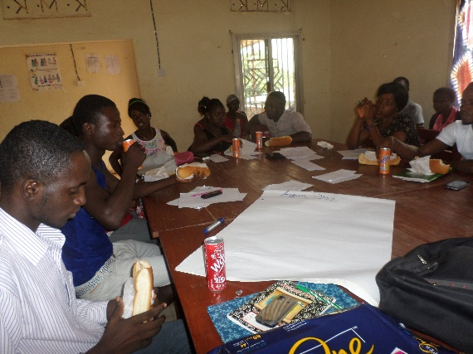
The Meetings held bi-monthly.

- Involved in Meetings Organized by other Agencies
Organisations who form the Child Right Coalition in which DCI SL is a member in Kabala and are focus on child participation and protection come together to have two different sector meetings once in a month to discuss and report on each organisational activity implemented in their operational areas within district. Every Organisation involved in child protection issues come together to meet at the Ministry of Social Welfare, Gender and Children’s Affairs (MSWGCA) who will Chair the meeting and another at NGO’s involved in education chaired by the Ministry of Education to report on the activities involving schools and these reports are sent to the government.
CYAB through DCI SL is given an opportunity to show case their activities within the district. The main focus of the project is involving children to participate fully in decision making processes. One of the objectives is to support advocacy work of children and youths in order to assist them contribute to addressing issues that affect them particularly at the local level.
Objective
- To report to Ministries every organizational activity within the district
- To create a support mechanism amongst organizations in different operational areas
- To address child right issues in the district.
Result
- The Ministries report every activity directly to the Government
- Each organization give support to partners according to their operational areas in solving issues
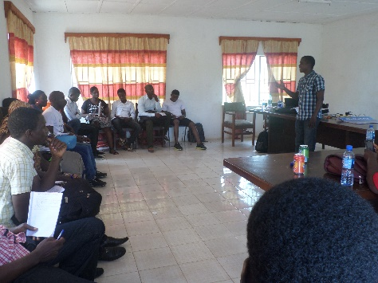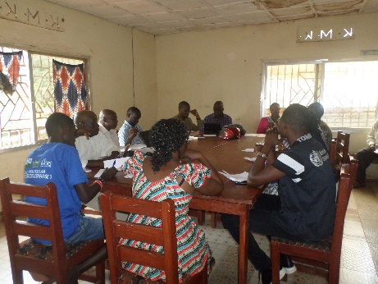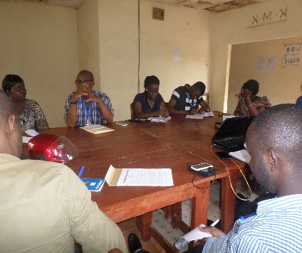
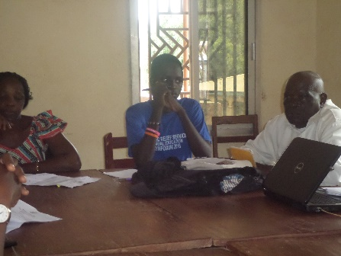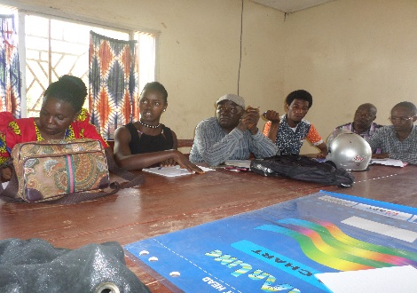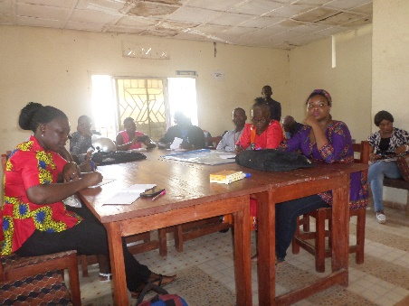
Sector Meetings Held at Ministry of Social Welfare and Ministry of Education

- Involved in Programs organized by other Agencies.
The main aim of the project is to have a functional, vibrant and influential network of children and youths in Kabala, a way of gaining recognition and working towards sustainability. CYAB members have been involved in other programs of other agencies like Plan International Sierra Leone, AMNET Sierra Leone, Catholic Relief Service and other CBO’s in Koinadugu addressing child related issues.
They implement activities under these agencies, in advocating through drama, radio programs and community engagement discussion programs. Recently CYAB was in the panel to launch the African Union to End Child Marriage Campaign and Mariama Bah represented Koinadugu in the National Event under the Office of the First lady.
In Koinadugu, CYAB who formed the panel drafted the position paper to end child marriage and was sponsored by Plan SL who champion the event.
These children are called upon always in the decision making processes because of their outstanding performance in working as a child group in the district. They are very active in their activities and are vigilant in identifying issues and addressing them.
Objectives
- To have an influential network of children to actively address children’s issue
- To have a sustainable group to work with the even after the project would have ended
- To improve on the activity of children in addressing issues
- Building on the capacity of the children to be self-reliant in addressing and advocating on issues.
- To show case the CYAB children talent and skills in every forum they find themselves.
- To represent the group and the project in other programs organized by other organizations
Result
- CYAB Children form part of other network of children organized by Agencies in addressing children issues at community level
- They actively work with child protection partners in addressing issues and also in decision making processes
- They represent the project at both district and national level.
- The CYAB group is well recognized in the district and their successes are well known.
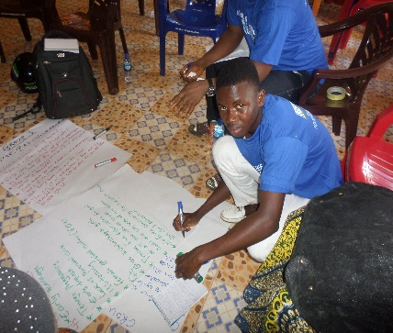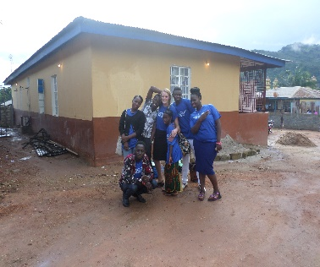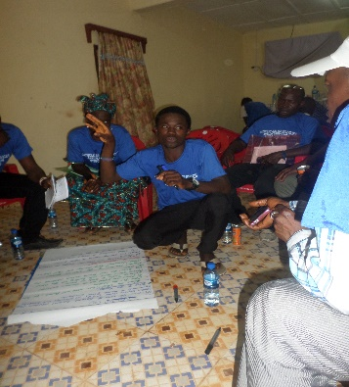 Working with Christian Relief Service on their Project on Education

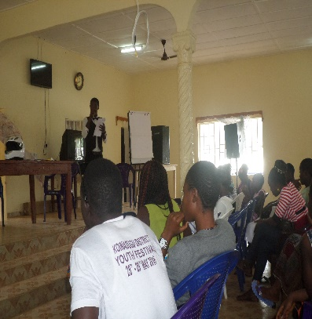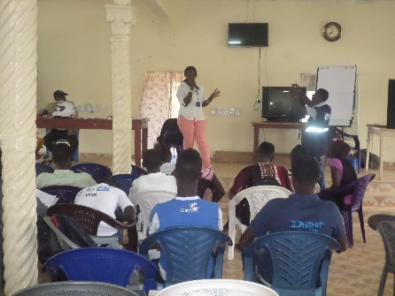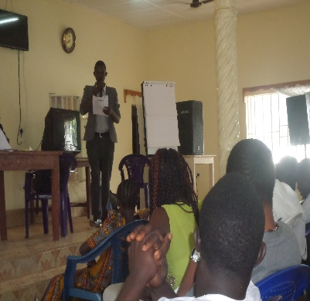
Developing Action Plan together with Plan SL on the project Ending Child marriage
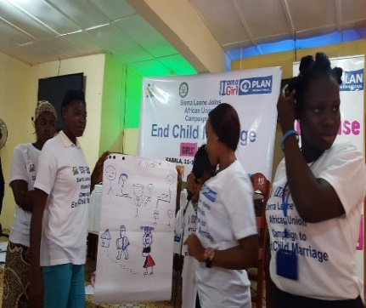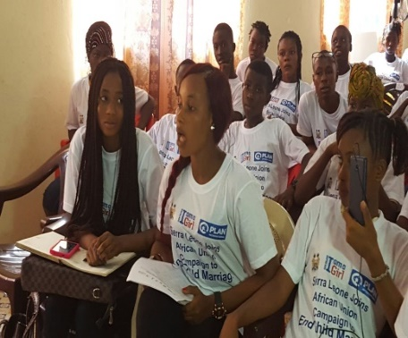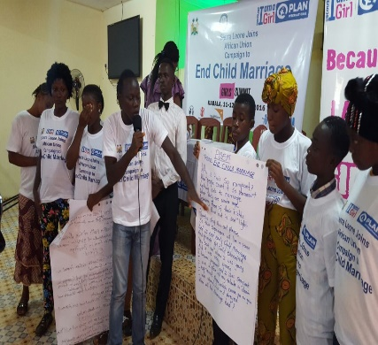
Attending the summit on Ending Child marriage organised by Plan SL in Koinadugu District.

Challenges
- CYAB is only active in the Kabala township and there is a demand for it to be established at chiefdom level
- Insufficient fund is limiting the activities of the project
- Untimely availability of fund prevented the CYAB members to observe the June 16 celebration in Kabala.

