Project: Strengthening Children and Youth Advocacy Board.
Organization Group: The Children and youth Advisory Board (CYAB), Kabala.
Date: August and September 2015 Report.
Activities:
- Work Shop on Child Abuse and Child Rights
- CYAB weekly meetings in preparation of the October 11 Day of the Girl.
- Organizing the International Day of the Girl, October 11
- Radio discussions
- Dialogue meeting with School Heads
- Picnic with the Group

- Work Shop on Child Abuse and Child Rights
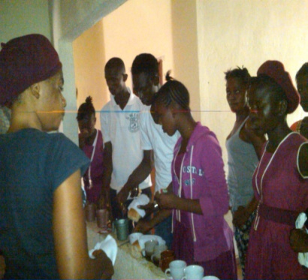
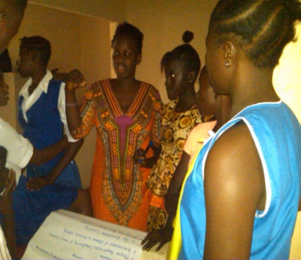
The children chose a date where in we organized a child friendly workshop in building on Life Skills Peer Influence and also discuss on the different Child Rights and Responsibilities. This workshop was championed by the children themselves and I was there to coordinate and guide them through each sessions. The children went on to research on issues affecting them in schools through peer influence and they did presentations on those issues.

Objective
- To remind them about the twelve rights of children and their Responsibilities.
- To increase knowledge amongst children in identifying what is are the bad things they gain from peer influence.
- To know about the effects and causes of child abuse and violence in community level
- To know possible solutions in stopping or preventing child abuse.
- To create a way of having a positive peer influence in school.
- To have knowledge on what they should be discussing in assemblies.
Result.
- Children are now aware their rights and responsibilities.
- They know the different types of abuses and violence they encounter in school, home and community
- Children learned how to influence their friends positively in school.
- They now know how to identify and report issues that affect them and who they should report to.
- Working together as a group in doing presentations brought unity, teamwork and friendship amongst them.
- The workshop created an atmosphere for reliability and confidence in discussing issues.
- It brought confidence and boldness for children to speak up in any forum.

- CYAB weekly meetings in preparation of the October 11 Day of the Girl.
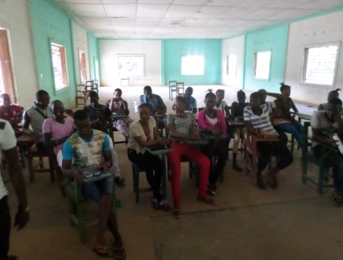
The meetings were always child friendly without much familiarities observed for children to be well comfortable and free in thinking what they want to discuss. On the chosen Wednesdays and Fridays children will come after school within the hours of 3:30pm to 5:30pm to hold the meeting and they themselves always moderate the meeting. This month the group is engaged in practicing drama to perform on the International Day of the Girl conference.

The meeting’s agenda goes like this;
- Arrival of children 3:30- 4:00pm
- Prayer
- Welcome Address (DCI-SL)
- Introduction of children and their different schools and roles they play.
- Issues discussed in previous meetings
- Cases identified in school and community
- Discussion on the Child Protection issues
- Identify advocacy issues from discussions above.
- Talent (song, poem, drama etc.)
- Closing prayer.
- Refreshment.
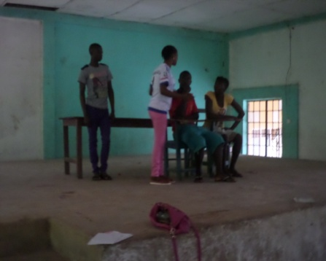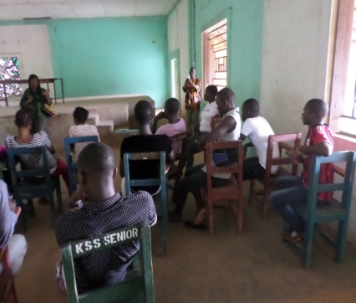

- Organizing the International Day of the Girl, October 11.
October 11 is the United Nations Day of the Girl. This year, as the international community assesses progress under the Millennium Development Goals (MDGs) since their implementation in 2000 and sets goals to be achieved by 2030, girls born at the turn of the millennium have reached adolescence, and the generation of girls born this year will be adolescents in 2030. As we reflect on the achievements of the past 15 years and plan sustainable development goals for the next 15, it is an opportune time to consider the importance of social, economic, and political investment in the power of adolescent girls as fundamental to breaking the intergenerational transmission of poverty, violence, exclusion and discrimination and to achieving equitable and sustainable development outcomes.
Adolescent girls have the right to a safe, educated, and healthy life, not only during these critical formative years, but also as they mature into women. If effectively supported during the adolescent years, girls have the potential to change the world both as the empowered girls of today and as tomorrow’s workers, mothers, entrepreneurs, mentors, household heads, and political leaders. An investment in realising the power of adolescent girls upholds their rights today and promises a more equitable and prosperous future, one in which half of humanity is an equal partner in solving the problems of climate change, political conflict, economic growth, disease prevention, and global sustainability.
As the global community launches the Sustainable Development Goals (SDGs) for implementation over the next 15 years, it is a good time to recognise the achievements made in supporting young girls, while at the same time aspiring to support the current and upcoming generation of adolescent girls, to truly fulfil their potential as key actors in achieving a sustainable and equitable world. In recognition of the importance of investing in adolescent girls’ empowerment and rights, both today and in the future, the theme of International Day of the Girl Child for 2015 is: The Power of the Adolescent Girl: Vision for 2030
With regards to the above, Defence for Children will be organizing different activities in developing the education of the girl. As a group, the children will be doing series of activities which will reflect on their education and social life. The Children and Youth Advisory Board will prepare A Position Paper which they will present on the conference day on issues affecting the girl child development.
Activity | Date
Radio Discussion on Awareness, Early marriage and teenage pregnancy | 17th September
School visitation | 21st September
Radio Discussion on Importance of Girl’s education, Poor parenting | 1st October
Debate competition for Junior Secondary Schools | 7th October
Radio discussion, Football game | 9th October
Radio Quiz competition, Match pass and conference, | 10th October

Debate schedule
Schools debating | Topic | For the motion | Against the motion
KSS & CRC | Girls can become better leaders than boys | CRC | KSS
AMASS & LOMA | Social media is negatively affecting girls education | LOMA | AMASS
UMC & Kabala Girls school | Pregnant girls should be allow to school | Girls school | UMC

Results
- Letters have being sent out to inform people about the program and also invite them to be part in observing the day.
- Football trainings for all NGO females team and the Nurses are ongoing.
- Radio Discussions still ongoing.

- Radio Discussions
Defence for children international has done two radio programs which are as follows;
- Defence for children was invited by the Bintumani Radio station through the BBC Media to discuss on the activities of the organization in Kabala. Questions asked about the background of the organization and the project. It was a one hour program from 7am to 8 am in the morning on the 16th September, 2015. Issues also affecting children were discussed and as organizations what do we do to solve most of the issues.

- Another radio program to discuss about the October 11 activity and also as an organization what have we put in place to observe the day. We discussed on topics like Importance of Girl’s education, Poor parenting. On the panel were Cause Canada, Catholic Relief Service and Defence for Children.

In each of the radio discussions, phone lines were opened and people called and made brilliant contributions.
Result
- The awareness of the existence of Defence for Children and also the project
- The awareness of the activities in observing October 11
- The discussion of the issues created awareness of community people and stakeholders to be know about the issues that affect children and how we are to solve these problems.

- Dialogue meeting with School Heads
A school visitation to different secondary schools to have a dialogue with the School Principals in addressing issues of corporal punishment, teachers harassing children for money, male teachers harassing girls and also issues the children feel is not comfortable with them.
Discussing with the principal I got to learn the measures they put in place to amend some of the issues. They also discussed about children who are involved in bad groups and how the influence other children. They all in common are happy about the project as this will create a change for these children.
Result
- More awareness of the existence of the organization and the project.
- Most of the problems they encounter as a school and with these we can know how to amend some of the issues.
- Picnic with the Group
On the 23rd September the day of Eid Mubarak the Muslim holiday, the children organized a picnic outing to have fun and also to create a bond of friendship and trust amongst themselves. They prepared their food and brought drinks, mobilized and went up a hill were they spent the whole day till 6pm. There was so much fun and laughter and the children played so many games each of these games was like girls competing against boys who can do it better. The essence of this outing was to relax their minds, build confidence and trust in them.
Result
- Developed a WhatSapp group for them to be having frequent communications.
- Playing games developed team spirit, unity, trust etc.

- Child protection agency’s meetings.
Because concerted effort to ensuring effective child protection will not succeed without coordination and partnership, DCI Kabala office thought it fit to join the child protection group in Kabala since September. Members of the group meet every Thursday to discuss issues affecting children and young women in the district and identify appropriate referral procedures depending on the case. DCI holds a strategic or an executive position in this group which have resulted to many success stories in the project that I being implemented in the Kabala Township. Some of the successes include but not limited to the following:
Results:
- It has increased the visibility of DCI in the District especially in the Kabala Township.
- It has increased the level of coordination amongst child protection partners responding to child protection issues in the district especially in the Kabala Township.
