THE YOUTH ADVOCACY NETWORK KABALA
ANNUAL ACTIVITY REPORT
2019
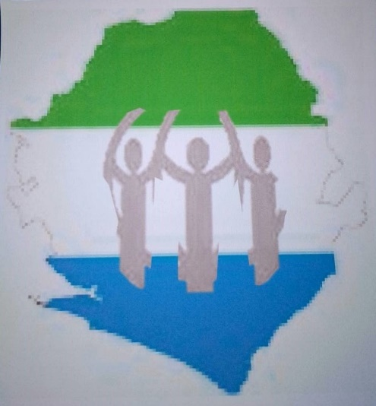

We thrive by positive Change

Table of contents

Preface 3
Pillars of the organization 4
Advocacy activities success and challenges 5
Looking forward 6

Preface

The Youth Advocacy Network (YAN) is a community-based organization, formed in 2017. And registered with the Koinadugu local council and both the ministry of youth affairs, and the ministry social welfare. And it is certified. The organization comprises of young persons within the ages of 15 to 35. At first, the organization was comprised of 35 members including 6 executive members, the aim of the organization is to create an influential and vibrant network among young persons and between youth and the community stakeholders. Such as including youth in governance, include women and young people in decision making process for a better gender inclusive society. Another pillar of the organization is advocacy, we saw that, there are people who are deprived access to certain basic human right facilities such as education and gender equality. As an organization full of young and enthusiastic advocates with no fear to talk anything real, we decided to stand for the rights and potentials of young people within the districts of Koinadugu and Falaba through advocacy and support on basic things such as school fees, school materials and leadership mentorship every Saturday in normal meetings sponsored by Stichting Taiama Andreas (STA) from The Netherlands. Presently the organization comprised of over 40 members both new and old.

Pillars of the organization

*Dedicated membership, for an organization, association, federation, or group to become sustainable, it must have die hearted dedicated members to keep emoving such organization. YAN has dedicated members in and out of Kabala, that are ready to keep the organization alive for yet unborn! This can be examined through few members that are in the university that are offering free computer class to members.
* School support program, as a youth organization comprised of majority school going pupils, YAN is undertaking robust school support within Koinadugu sponsored by STA who knows that education is the key to support advocacy, fight poverty and create awareness.
And also, STA supported some YAN members to meddle man power through job skills at FAWE to reduce age dependence

*The Office and its equipment, in 2018 STA rented an office for YAN where normal meetings are held and bought furniture eg chairs and tables, learning materials such as text books, a desktop donated from Kelly’s brother and a laptop in 2019 from STA and many more.

Advocacy activities success and challenges

In 2019 YAN proposed 12 activities on advocacy, but due to inadequate funding with STA, they approved 4 and YAN undertook some without funding from STA. In 2019 YAN as a group was active at the national cleaning day in May and in October. Out of the 4 activities, STA supported two YAN raised funding for 1 and the 1 was skipped because of detailed explanation of YAN and misunderstanding from STA.
There was the Foundation Day in August, celebrated at the office. YAN invited some important stakeholders. YAN members gave a presentation about what YAN stands for and what YAN has achieved. Together they looked at the future of YAN and how YAN and stakeholders can work together in the future for the improvement for the youth of Kabala.
On October 11, International Day of the Girl, YAN members went to Semamaya Village to talk about Teenage Pregnancy. In the week before October 11, YAN members learned a lot about the danger of girls becoming pregnant at an early age. This was directed by an older female YAN member. On October 11 there was a drama, performed by younger YAN girls.
December 3th, the day of people living with disabilities was also a success. The money to organize this day was donated by stakeholders and other people from Kabala. With this YAN has proved that it doesn’t fully depend on aid from abroad. YAN went to the blind school. There was drama, there were discussions and YAN and the blind had a meal together.
Success on that day
*community people get understand that disable are human like us not witch .
*The principal wants the blinds to be part of YAN (members).
With all these challenges, during the advocacy activities lots was achieved than lost.

Looking forward

For 2020, we are seeing more progress than 2019 although, there is global challenge in the first quarter of 2020 we undertook 1 activity successfully sponsored by STA and lots of good plans have been made but now we have pause due to the CORONA pandemic that affects all works of life globally.
*The relationship between STA and YAN is more than just as organizations, we are both learning from each other from two different countries of different cultures and languages. But yes we are connected and simply understand each other, although YAN is learning yes STA respect that and we pray things improve.

Don by the acting secretary general,
Lamin Mansaray.

